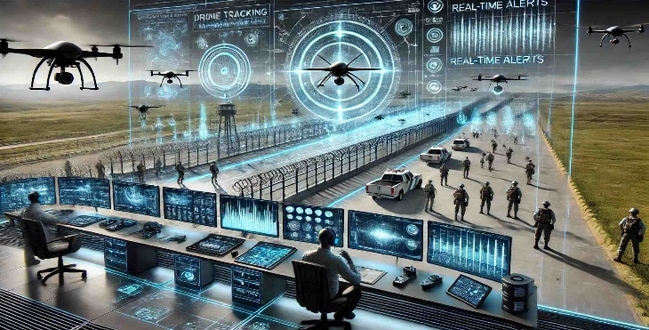
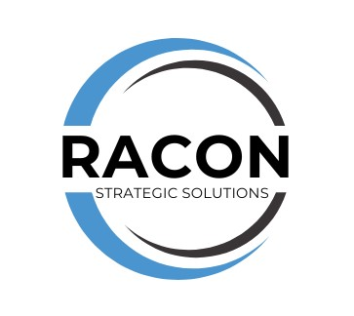

Racon Strategic Solutions: Enhancing United States Border Patrol Operations
Racon Strategic Solutions Virtual Command Center (VCC) leveraging cutting-edge Artificial Intelligence (A) technologies to assist the United States Border Patrol to fortify operations and strengthen national security. The VCC provides real-time responsiveness, scalability, and immediate intervention capabilities, helping to ensure a safer and more secure border environment.

Key Areas of Focus
- Real-time and Historical Video Sharing: Provide enhanced situational awareness with both real-time and historical video sharing capabilities to facilitate the tracking and identification of criminals and potential security threats.
- Gun Detection and Crowd Facial Recognition Tracking: Provide precise, real-time notifications of gun detection and real time biometric identification/facial recognition in both crowded and remote areas.
- Advanced Intrusion Detection and Tracking: Racon’s cutting-edge technology utilizes Edge Artificial Intelligence (AI) to provide real-time situational awareness that could identify and track individuals attempting to illegally cross the U.S. border.
- Multi-Agency Collaboration and Communication: Seamless communication and collaboration between Border Patrol agents and other national, state and local law enforcement stakeholders through multi-party video conferencing and instant messaging.
- AI-Driven Threat Detection and Alerting: Expertly leverage AI-driven threat detection and alerting capabilities to identify potential security threats such as drug trafficking, human smuggling, and terrorist activity.
- Drone Assisted Tracking: With the support of Drone Assisted Tracking, identify and track those attempting to smuggle humans or contraband across the U.S. border.

Benefits
- Enhanced Situational Awareness: VCC’s AI-driven technologies can provide the U.S. Border Patrol with real-time insights and actionable intelligence to inform decision-makers and optimize response efforts.
- Improved Interagency Collaboration and Communication: Foster seamless communication and collaboration between Border Patrol agents, law enforcement agencies, and other stakeholders, to ensure unified and effective response to potential security threats.
- Predictive Analytics and Threat Forecasting: Leverage predictive analytics and threat forecasting capabilities to anticipate and prepare for potential U.S. border security threats. These capabilities enhance agent safety and assist in providing proactive and effective border security operations.

The Advantage of AI-Powered Drone Assisted Detection
Compared to manual tracking methods, Racon Strategic Solutions' AI-powered drone assisted detection and tracking capability offers enhanced accuracy, speed, and reliability. This advanced feature enables Border Patrol agents to:
- Rapidly detect and track targets utilizing drones: AI-powered drone assisted detection and tracking capabilities provide real-time alerts and tracking data, enabling agents to respond quickly and effectively.
- Improve situational awareness: Advanced drone assisted detection and tracking capabilities provide enhanced situational awareness, enabling agents to anticipate and prepare for potential security threats.
- Enhance operational efficiency: AI-powered drone assisted detection and tracking capabilities streamline border security operations, reducing the need for manual tracking and enabling agents to focus on higher-priority tasks.
By leveraging Racon Strategic Solutions' AI-powered drone assisted detection and tracking capability, United States Border Patrol can enhance its ability to detect and respond to potential security threats, ensuring a safer and more secure border environment.

